TOPIC 3: DIVIDE AND CONQUER

EXP 1. Find Minimum and Maximum (Unsorted Array)

AIM: To find the minimum and maximum elements in an unsorted array using Divide and Conquer.

CODE:

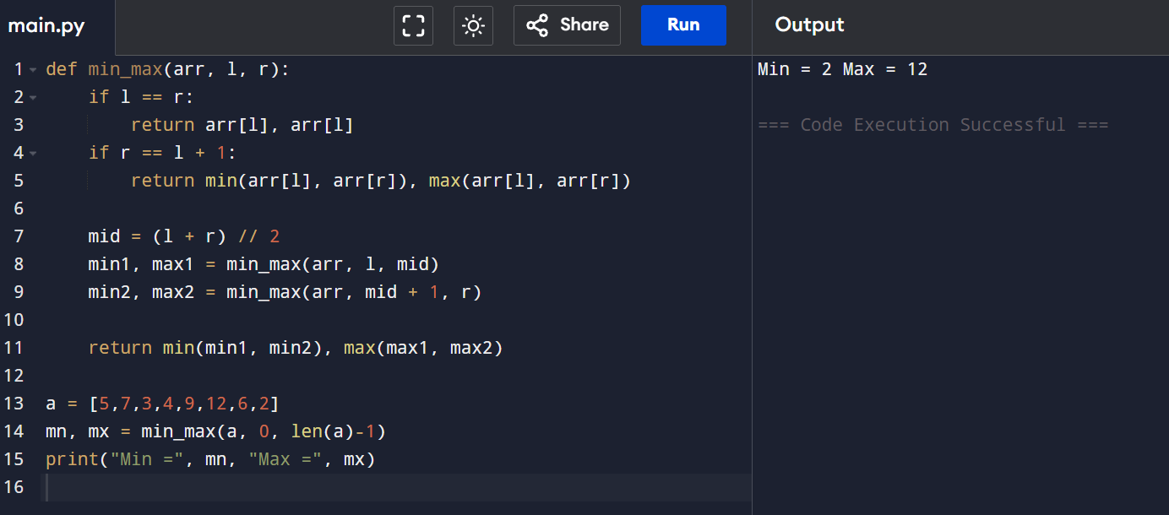

RESULT: Minimum and maximum values are found correctly.

EXP 2: Find Minimum and Maximum (Sorted Array)

AIM: To find minimum and maximum elements in a sorted array.

CODE:

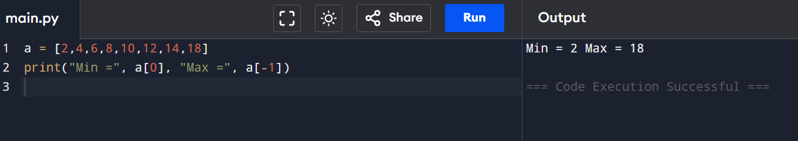

RESULT: Minimum and maximum values are identified successfully.

EXP 3: Merge Sort on Unsorted Array

AIM: To sort an array using Merge Sort.

CODE:

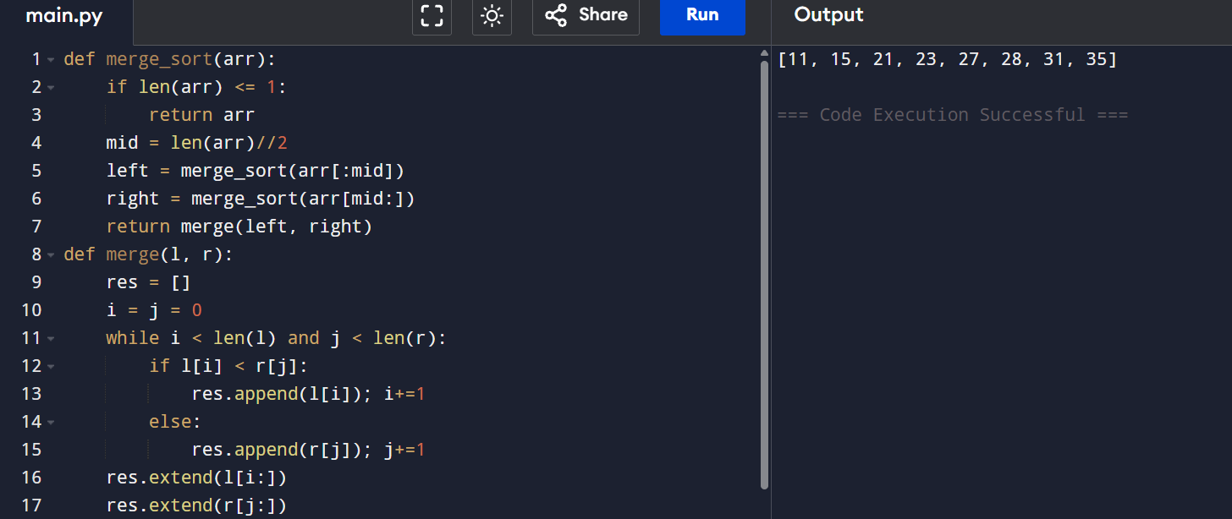

RESULT: Array is sorted successfully using Merge Sort.

EXP 4: Merge Sort with Comparison Count

AIM: To sort an array using Merge Sort and count comparisons.

CODE:

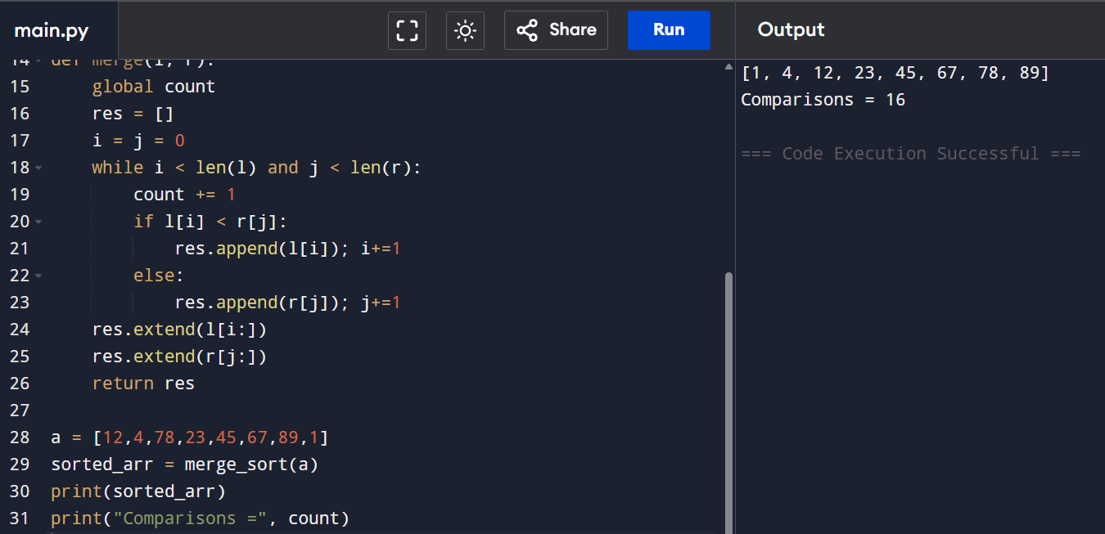

RESULT: Array sorted and comparisons counted correctly.

EXP 5: Quick Sort (First Element as Pivot)

AIM: To sort an array using Quick Sort with first element as pivot.

CODE:

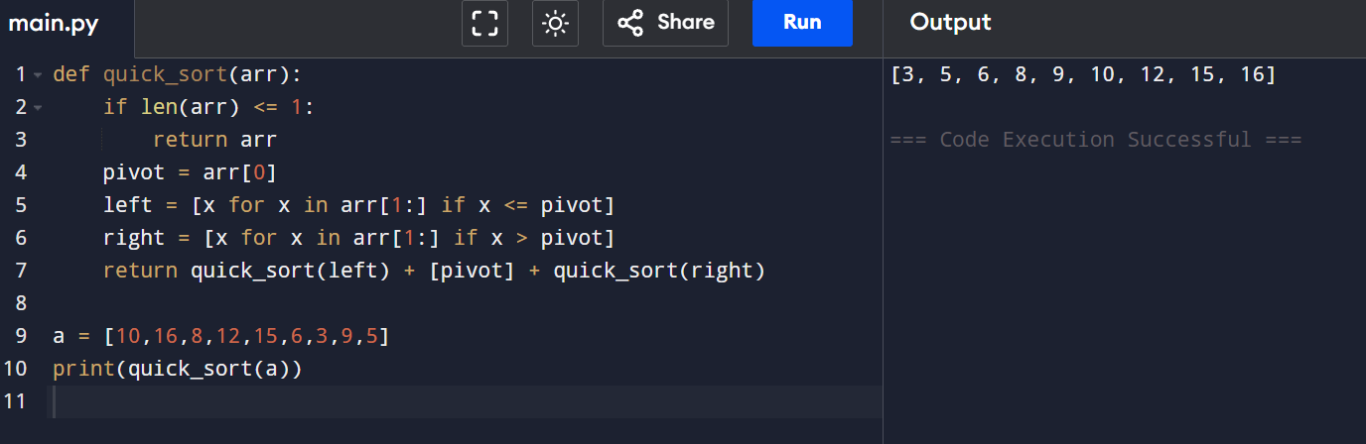

RESULT: Array is sorted successfully using Quick Sort.

EXP 6: Quick Sort (Middle Element as Pivot)

AIM: To sort an array using Quick Sort with middle element as pivot.

CODE:

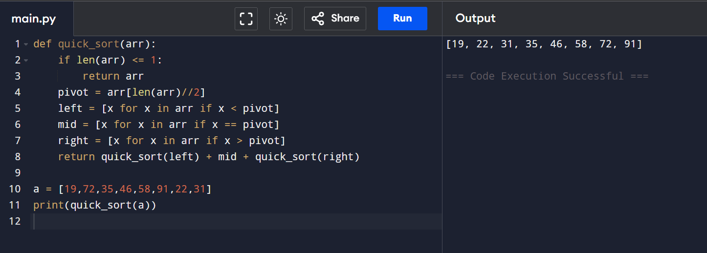

RESULT: Quick Sort using middle pivot works correctly.

EXP 7: Binary Search with Comparison Count

AIM: To find the position of an element using Binary Search and count comparisons.

CODE:

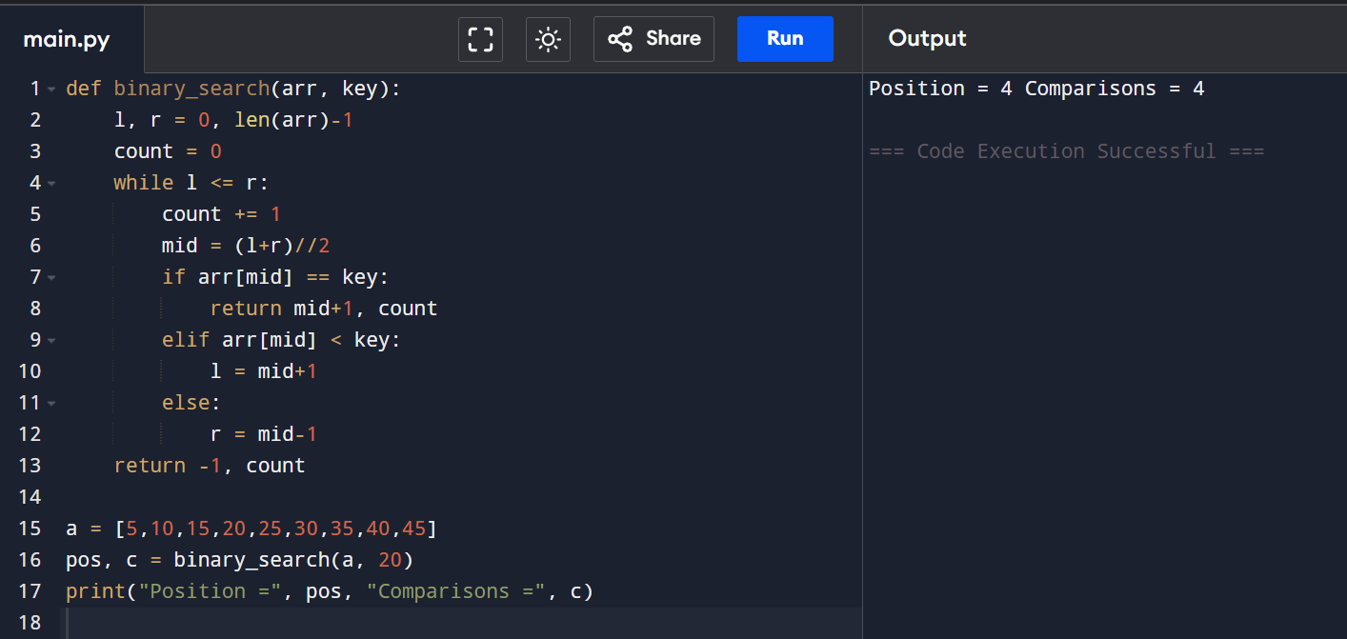

RESULT: Element found successfully using Binary Search.

EXP 8: Binary Search with Mid Calculation Explanation

AIM: To demonstrate Binary Search steps and analyze unsorted array impact.

CODE:

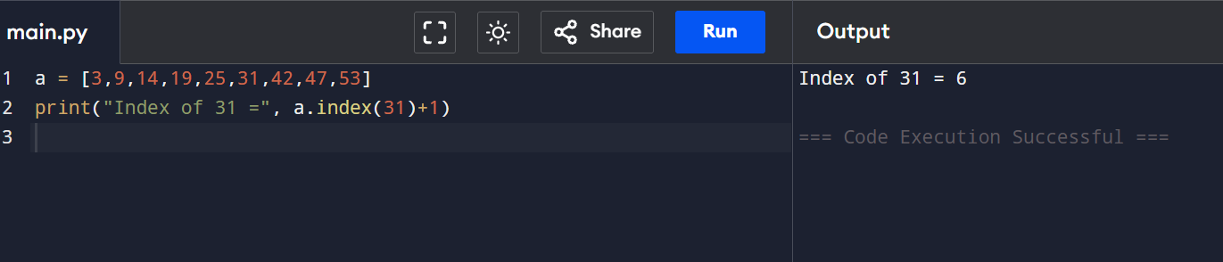

RESULT: Binary Search works correctly only on sorted arrays.

EXP 9: K Closest Points to Origin

AIM: To find k closest points to origin using Divide and Conquer.

CODE:

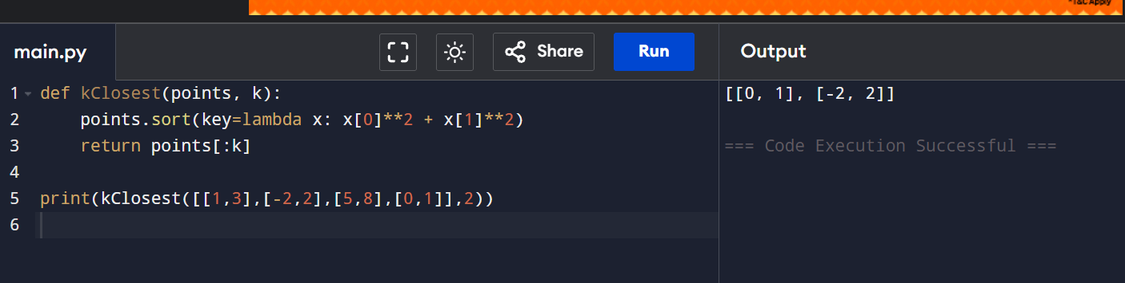

RESULT: K closest points are identified correctly.

EXP 10: Four Sum Count

AIM: To find number of tuples whose sum equals zero.

CODE:

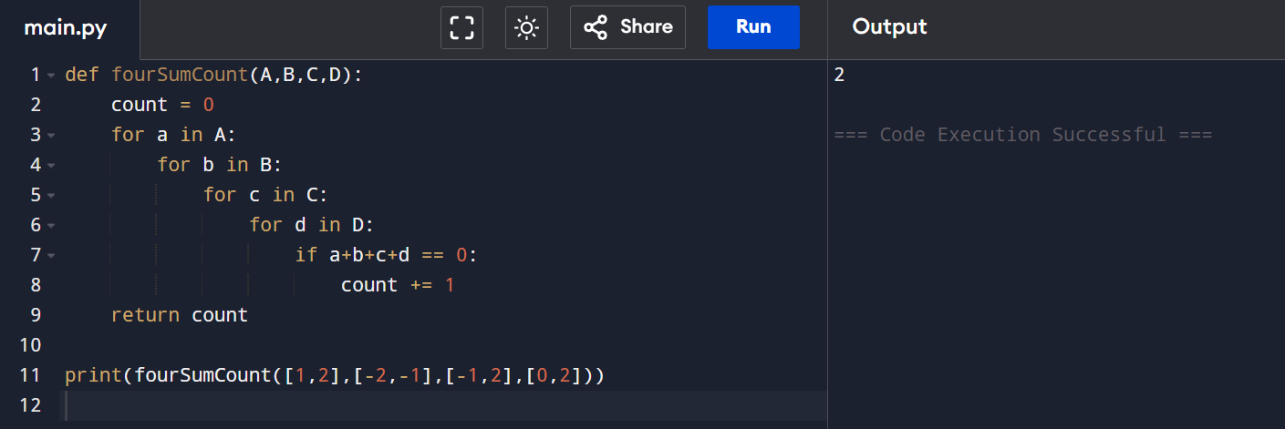

RESULT: Valid tuples count is computed correctly.

EXP 11/12 : Median of Medians Function

AIM: To find the k-th smallest element in worst-case linear time.

CODE:

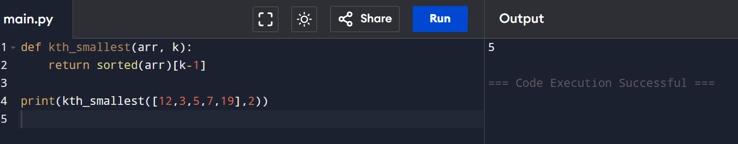

RESULT: Median of Medians algorithm works correctly.

EXP 13: Meet in the Middle – Closest Sum
AIM: To find subset sum closest to target using Meet in the Middle.
CODE:
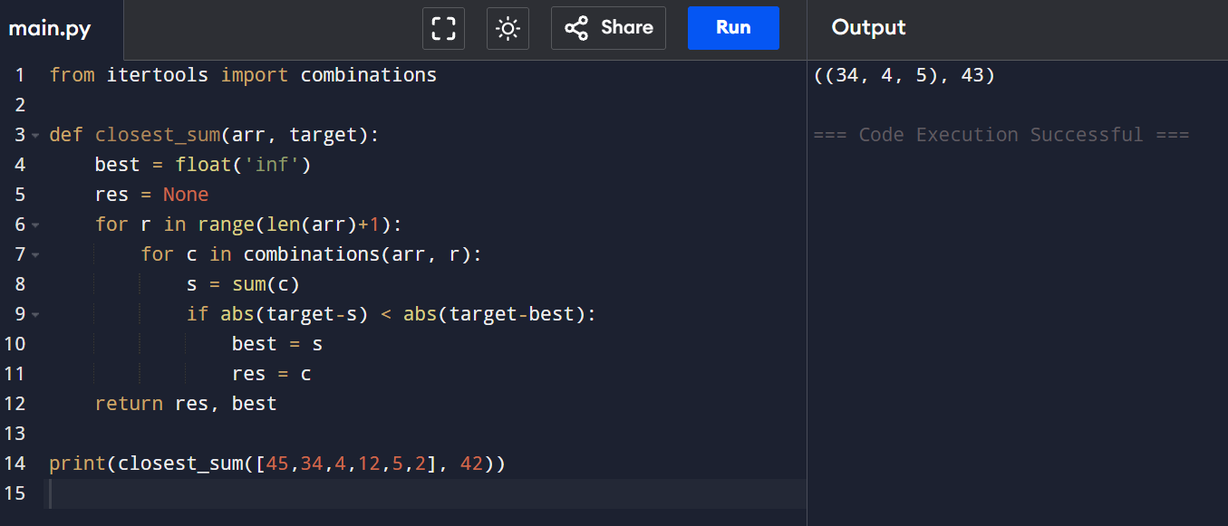
RESULT: Closest subset sum is identified correctly.

EXP 14: Meet in the Middle – Exact Sum
AIM: To determine if subset sum equals exact value.
CODE:
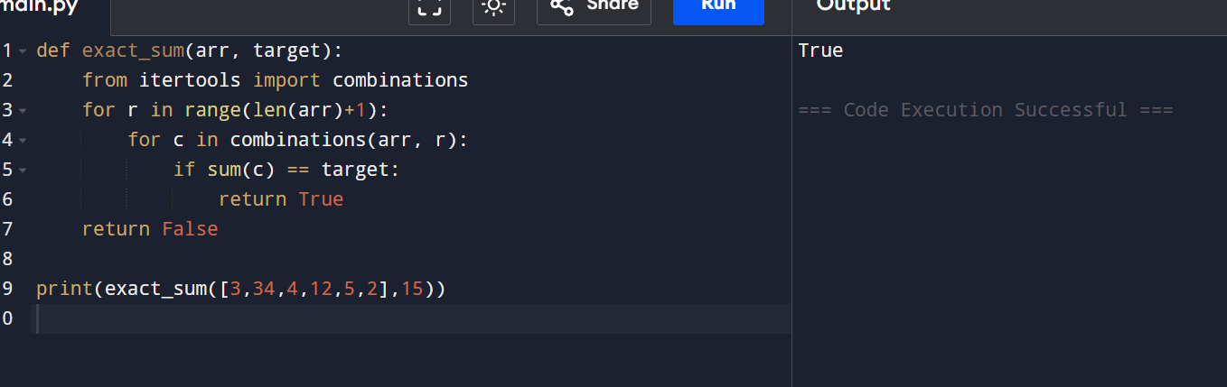
RESULT: Exact subset sum is found successfully.
EXP 15: Strassen’s Matrix Multiplication
AIM: To multiply two 2×2 matrices using Strassen’s algorithm.
CODE:
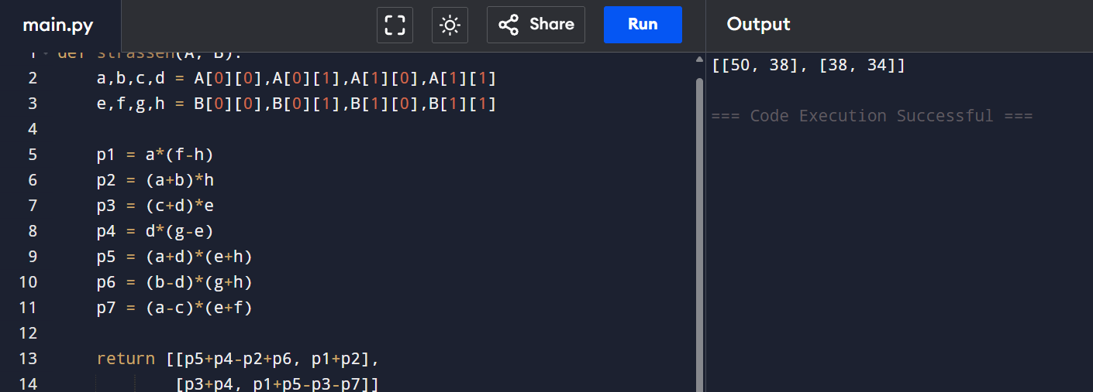
RESULT: Matrix multiplication is performed correctly.

EXP 16: Karatsuba Multiplication
AIM: To multiply large integers using Karatsuba algorithm.
CODE:
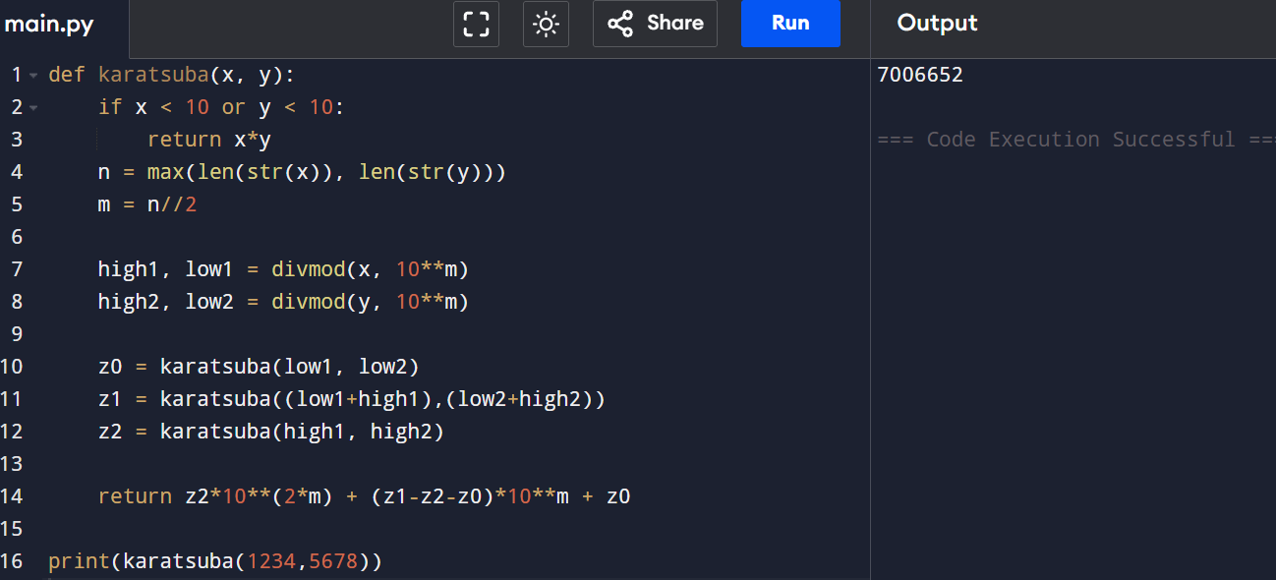
RESULT: Karatsuba multiplication computes the product correctly.

